NEURAL NETWORKS AND DEEP LEARNING -22ITE13
ACTIVITY-2
TOPIC: Speech Emotion Recognition
NAME : SATHIYA S
REG.NO : 732923ITR094
CLASS : 23IT5B
PROGRAM:
import torch
import torch.nn as nn
import torch.optim as optim
import matplotlib.pyplot as plt
x_data = torch.tensor([
[[1, 2, 3], [0, 1, 0], [1, 1, 1], [0, 0, 1]],
[[0, 0, 1], [1, 0, 1], [0, 1, 0], [1, 1, 1]],
[[1, 1, 0], [0, 1, 1], [1, 0, 1], [0, 0, 0]],
[[0, 1, 1], [1, 1, 0], [0, 0, 1], [1, 0, 1]],
[[1, 0, 0], [0, 1, 0], [1, 1, 1], [0, 1, 1]],
[[0, 0, 0], [1, 0, 1], [0, 1, 1], [1, 1, 0]],
], dtype=torch.float32)
y_data = torch.tensor([1, 0, 1, 0, 1, 0], dtype=torch.long)
class RNN_Model(nn.Module):
def __init__(self, input_size, hidden_size, num_layers, num_classes):
super(RNN_Model, self).__init__()
self.rnn = nn.RNN(input_size, hidden_size, num_layers, batch_first=True)
self.fc = nn.Linear(hidden_size, num_classes)
def forward(self, x):
h0 = torch.zeros(1, x.size(0), hidden_size)
out, _ = self.rnn(x, h0)
out = out[:, -1, :]
return self.fc(out)
class LSTM_Model(nn.Module):
def __init__(self, input_size, hidden_size, num_layers, num_classes):
super(LSTM_Model, self).__init__()
self.lstm = nn.LSTM(input_size, hidden_size, num_layers, batch_first=True)
self.fc = nn.Linear(hidden_size, num_classes)

def forward(self, x):
h0 = torch.zeros(1, x.size(0), hidden_size)
c0 = torch.zeros(1, x.size(0), hidden_size)
out, _ = self.lstm(x, (h0, c0))
out = out[:, -1, :]
return self.fc(out)

4. Training Function (return loss history)
def train(model, x, y, epochs=20):
criterion = nn.CrossEntropyLoss()
optimizer = optim.Adam(model.parameters(), lr=0.01)
loss_history = []
for epoch in range(epochs):
optimizer.zero_grad()
outputs = model(x)
loss = criterion(outputs, y)
loss.backward()
optimizer.step()
loss_history.append(loss.item())
return loss_history
5. Evaluation
def evaluate(model, x, y):
with torch.no_grad():
outputs = model(x)
_, predicted = torch.max(outputs, 1)
acc = (predicted == y).sum().item() / len(y) * 100
return acc
6. Run Models and Plot
input_size = 3
hidden_size = 5
num_layers = 1
num_classes = 2
epochs = 20
RNN
rnn_model = RNN_Model(input_size, hidden_size, num_layers, num_classes)
rnn_loss = train(rnn_model, x_data, y_data, epochs)
rnn_acc = evaluate(rnn_model, x_data, y_data)
LSTM
lstm_model = LSTM_Model(input_size, hidden_size, num_layers, num_classes)
lstm_loss = train(lstm_model, x_data, y_data, epochs)
lstm_acc = evaluate(lstm_model, x_data, y_data)
7. Plot Loss Curves
plt.plot(range(1, epochs+1), rnn_loss, label='RNN Loss')
plt.plot(range(1, epochs+1), lstm_loss, label='LSTM Loss')
plt.xlabel('Epoch')
plt.ylabel('Loss')
plt.title(f'RNN vs LSTM Training Loss\nRNN Acc={rnn_acc:.1f}%, LSTM Acc={lstm_acc:.1f}%')
plt.legend()
plt.show()

OUTPUT:
Training RNN...
Epoch 5/20, Loss: 0.5814
Epoch 10/20, Loss: 0.4708
Epoch 15/20, Loss: 0.3335
Epoch 20/20, Loss: 0.1911
RNN Accuracy: 100.00%

Training LSTM...
Epoch 5/20, Loss: 0.6815
Epoch 10/20, Loss: 0.6626
Epoch 15/20, Loss: 0.6317
Epoch 20/20, Loss: 0.5844
LSTM Accuracy: 100.00%
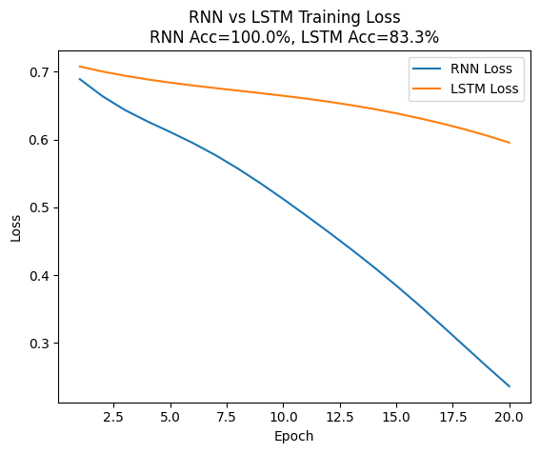
GITHUB LINK

